Bash Scripting – 2
1.create a bash script to check if a directory is available or not.
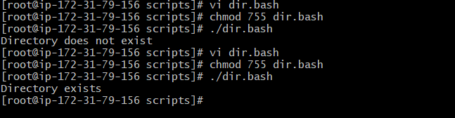
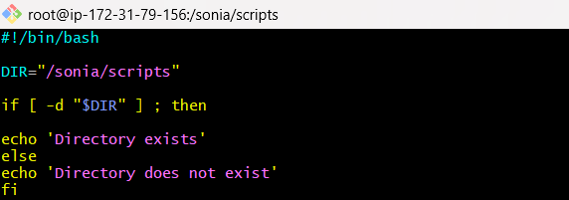
2.Create a Bash script which will create multiple files.
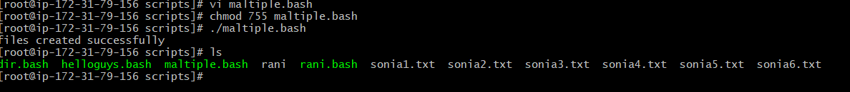
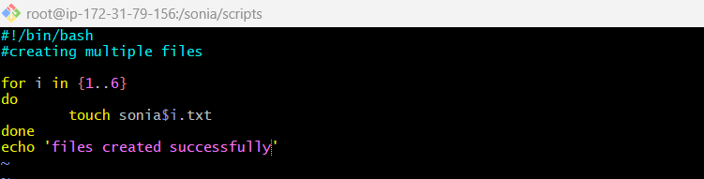
3.Create a Bash script to take backup of a directory.
4.Create a Bash script to install nginx in an EC2 server
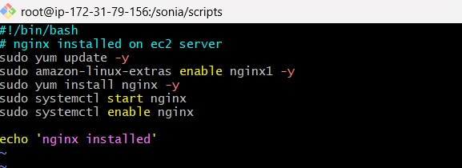
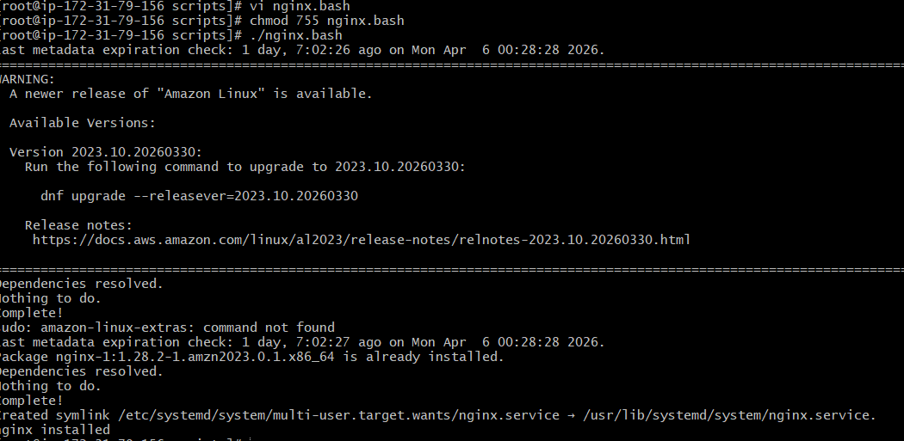
5.Create a Bash script to install Apache Tomcat in an EC2 server.
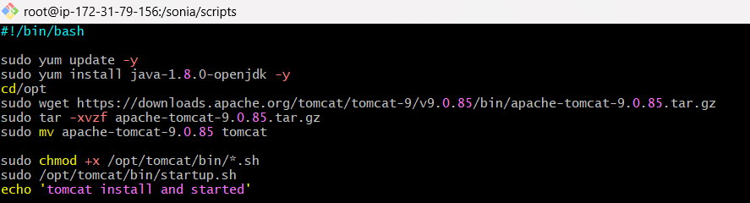
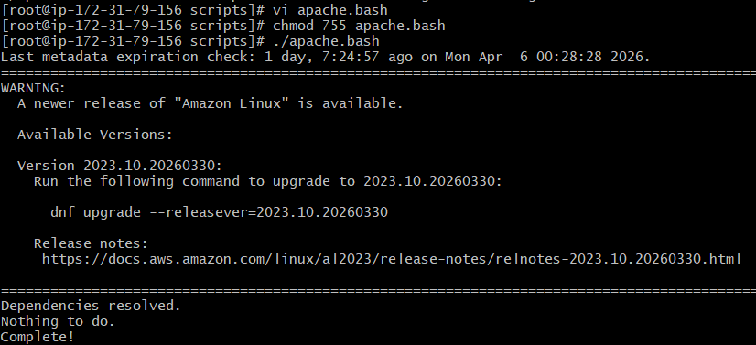
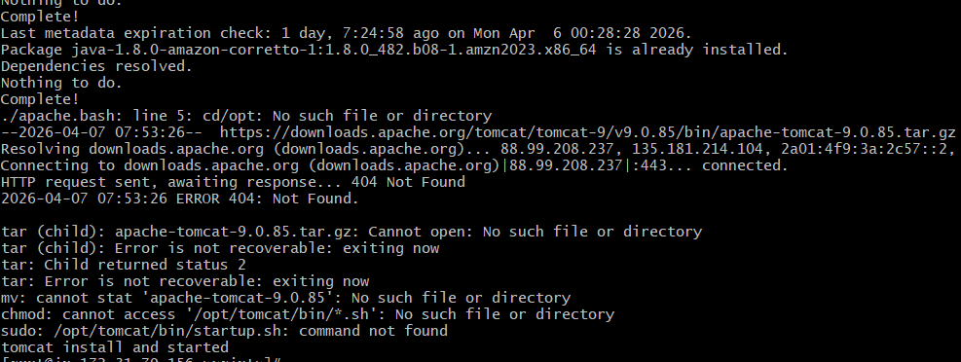
6. Create a bash script to check if the Nginx service is running, if not running then script should start the service.
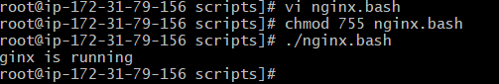
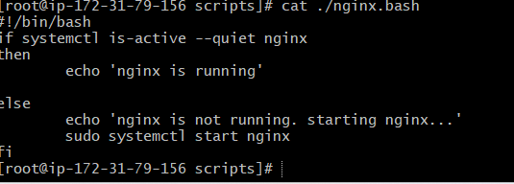
7.Create a bash script for a calculator.
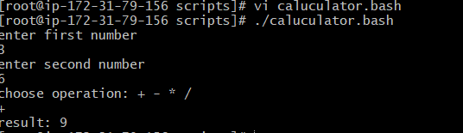
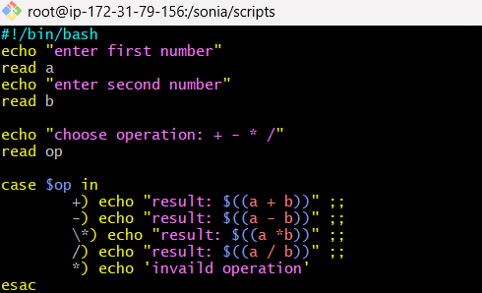
8. Create a bash script to check if a directory exists, if not then create a directory.
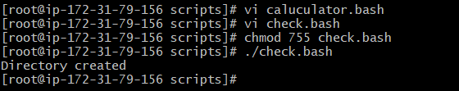
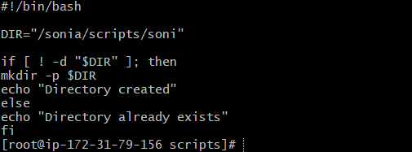
9. Create a bash script to delete the last 3 lines of a file.
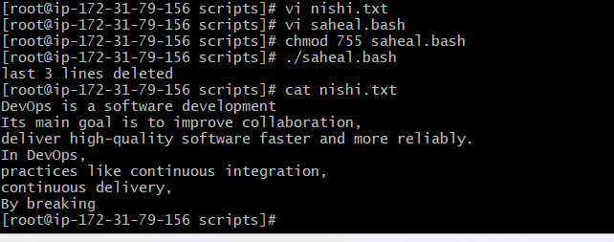
10.Bash script to monitor cpu and if it is more than 80% then send email notification.
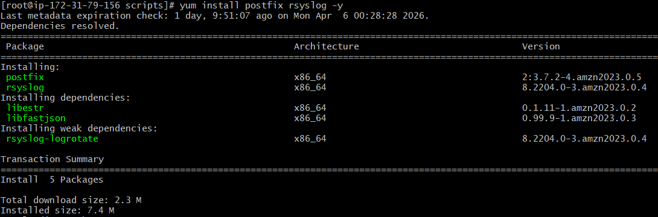
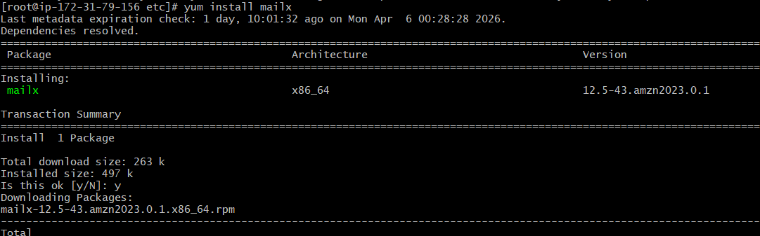
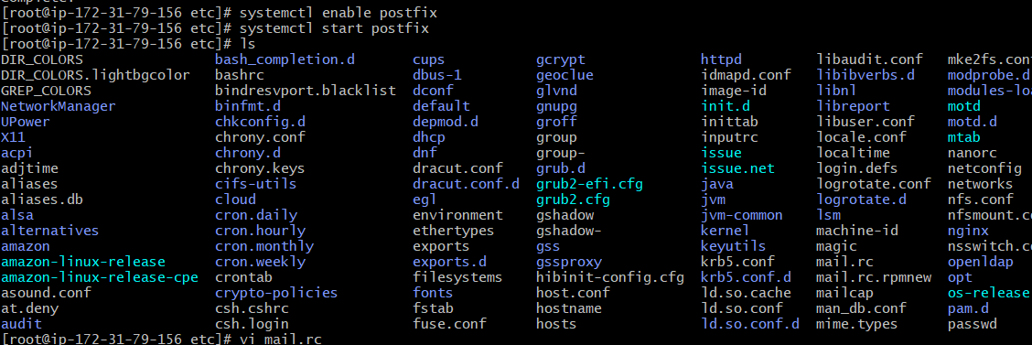


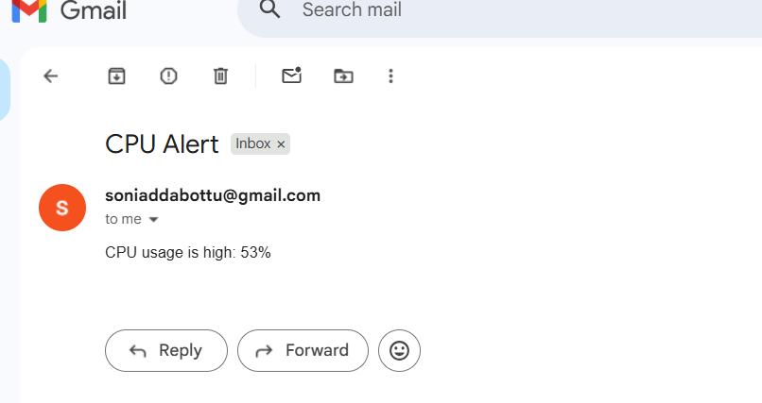
- Bash script to monitor disk space and if it is more than 80% then send email notification.
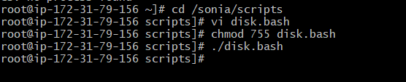
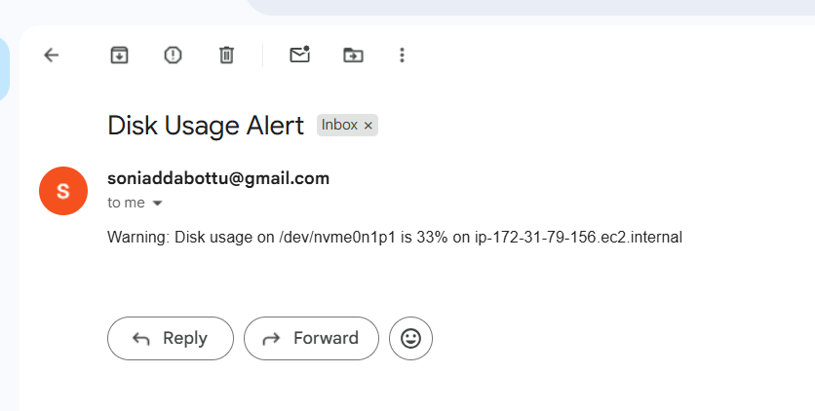

- Bash script to monitor memory and if it is more than 80% then send email notification.
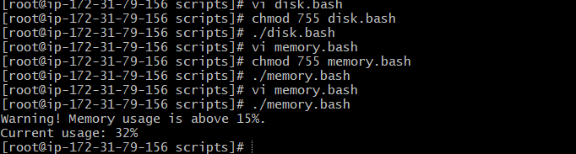

Crontab Entries
Firt we can install cronie -y
Sudo yum install cronie -y
Sudo systemctl enable crond
Sudo systemctl start crond
Sudo systemctl status crond
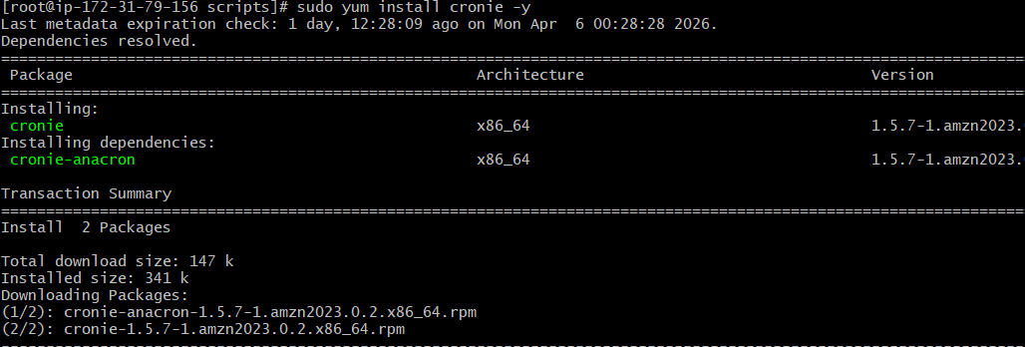
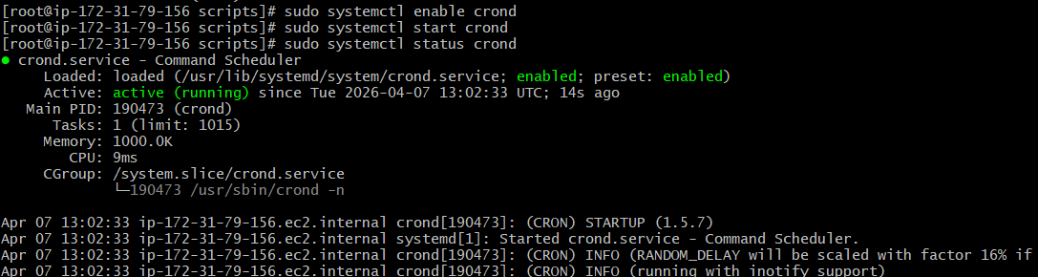

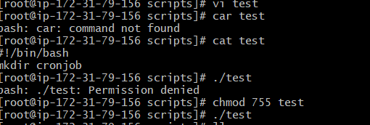
We have to enter crontab -e
Next what we enter we can use crontab -l
